Basics of Windows Server and Active Directory

Tasks

1. Install Windows Server on a virtual machine using VirtualBox or VMware and take a screenshot of the desktop after the installation completes.

ANS:

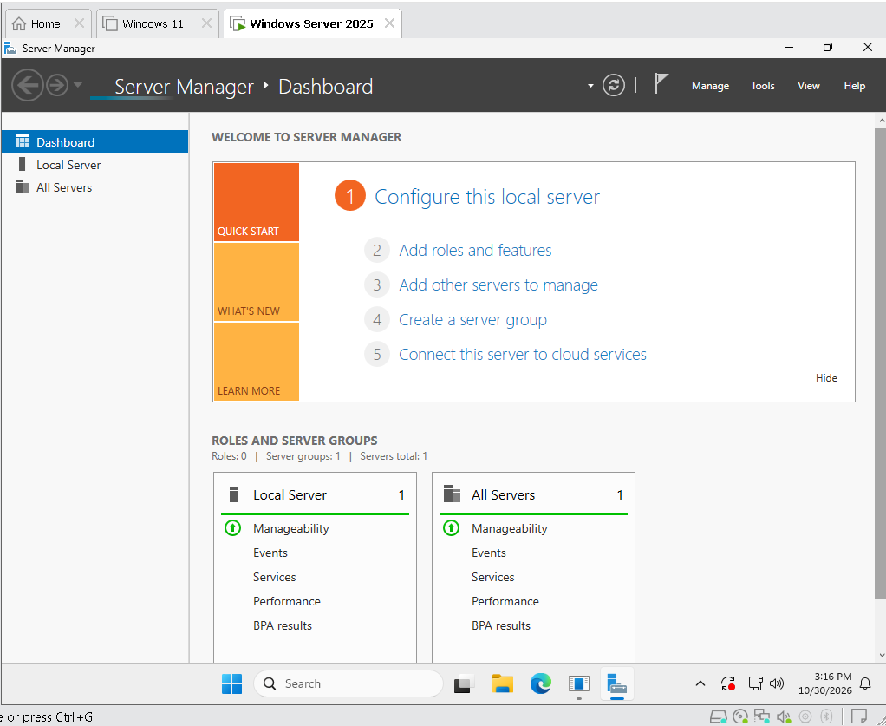

2. Open Server Manager and use the 'Add roles and features' wizard to install the Active Directory Domain Services (AD DS) role. Document each step with a short description and screenshot.

ANS:

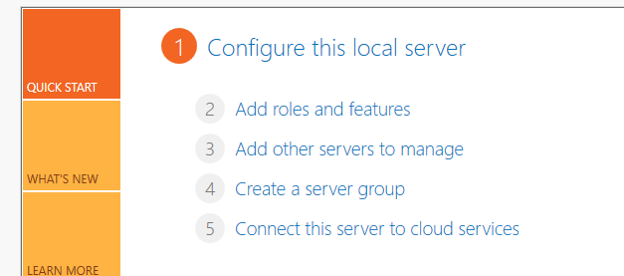

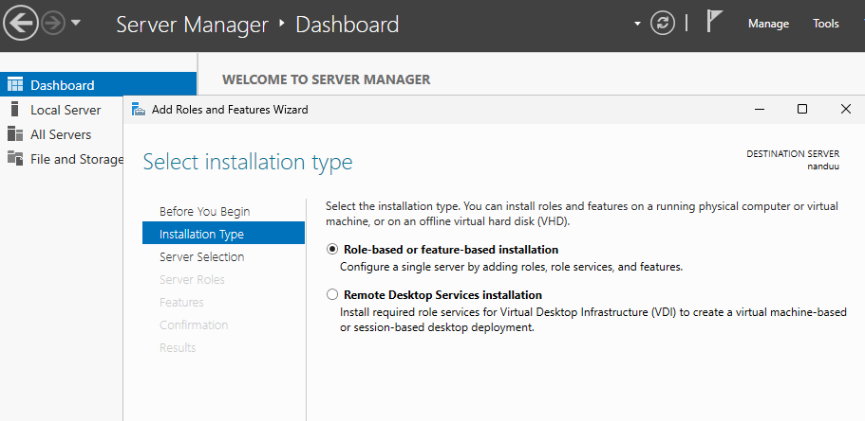

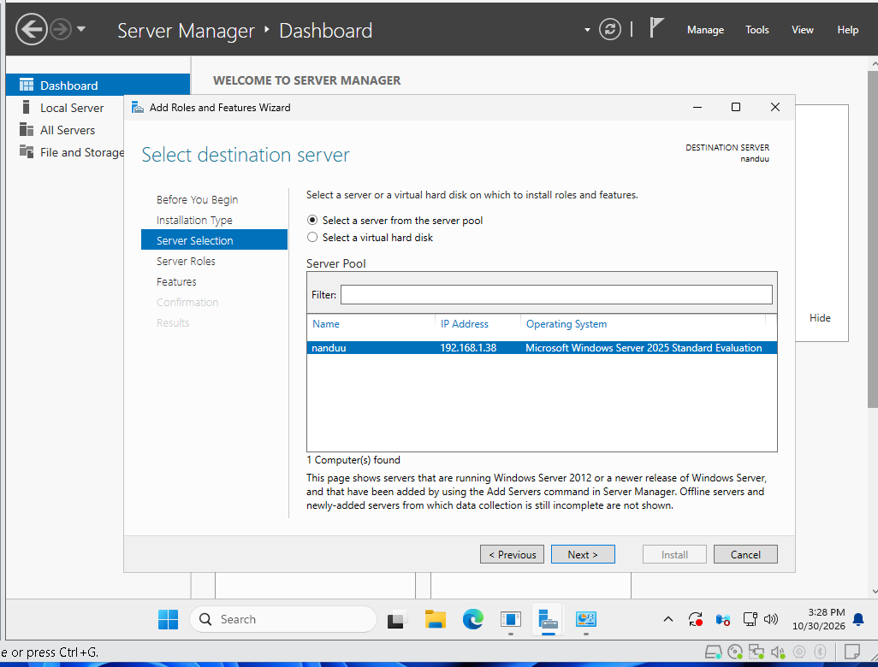

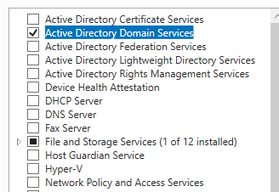

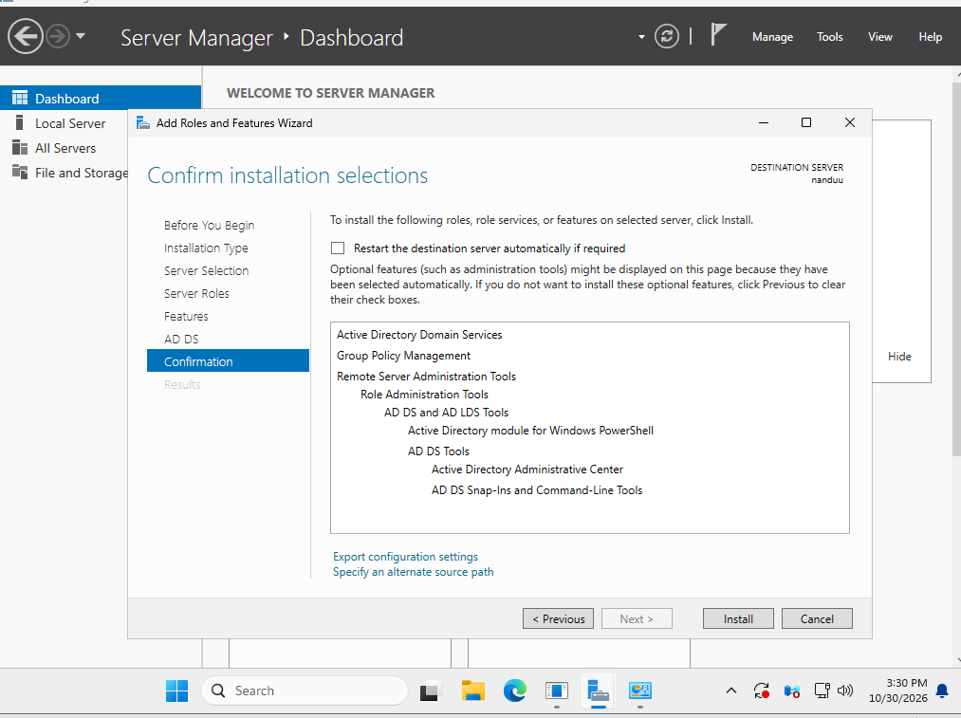

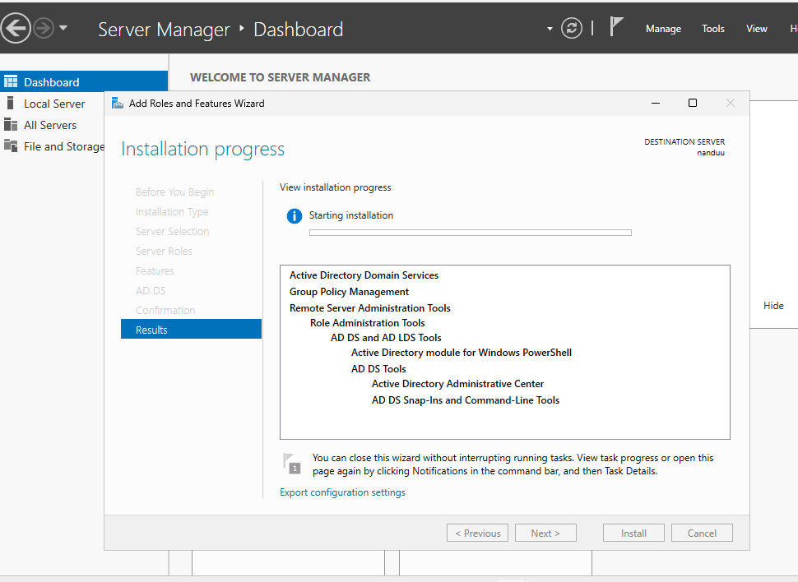

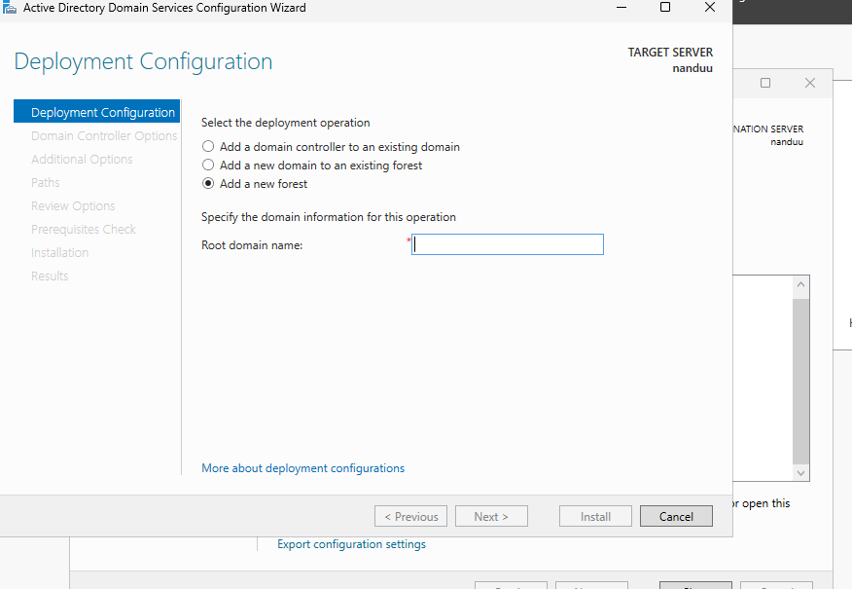



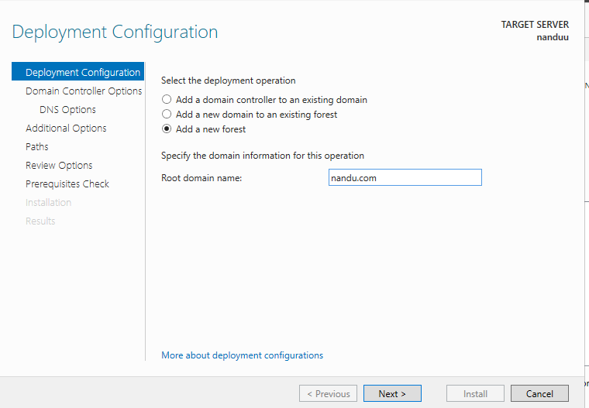

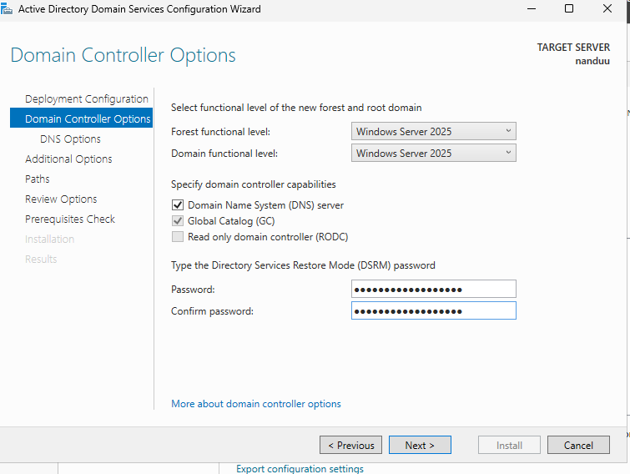

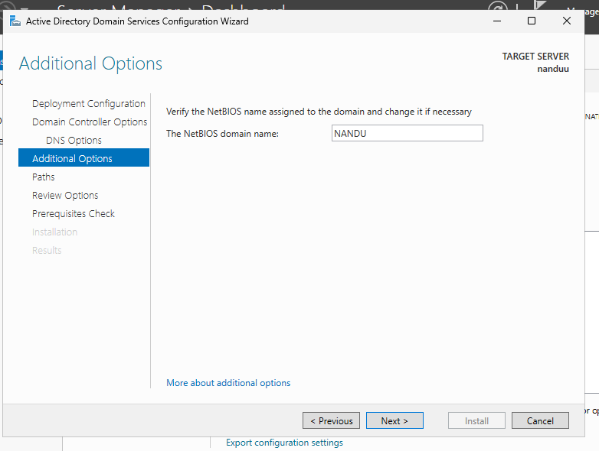

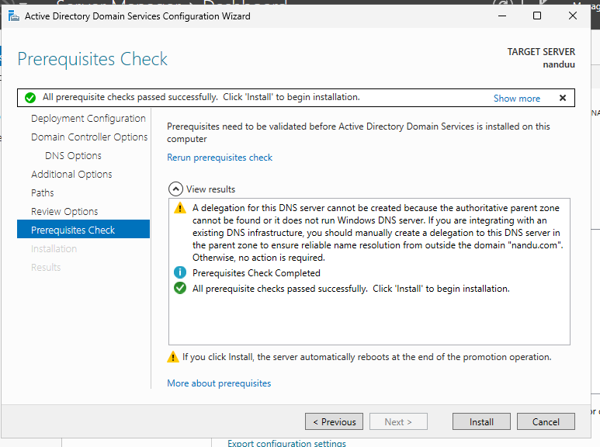

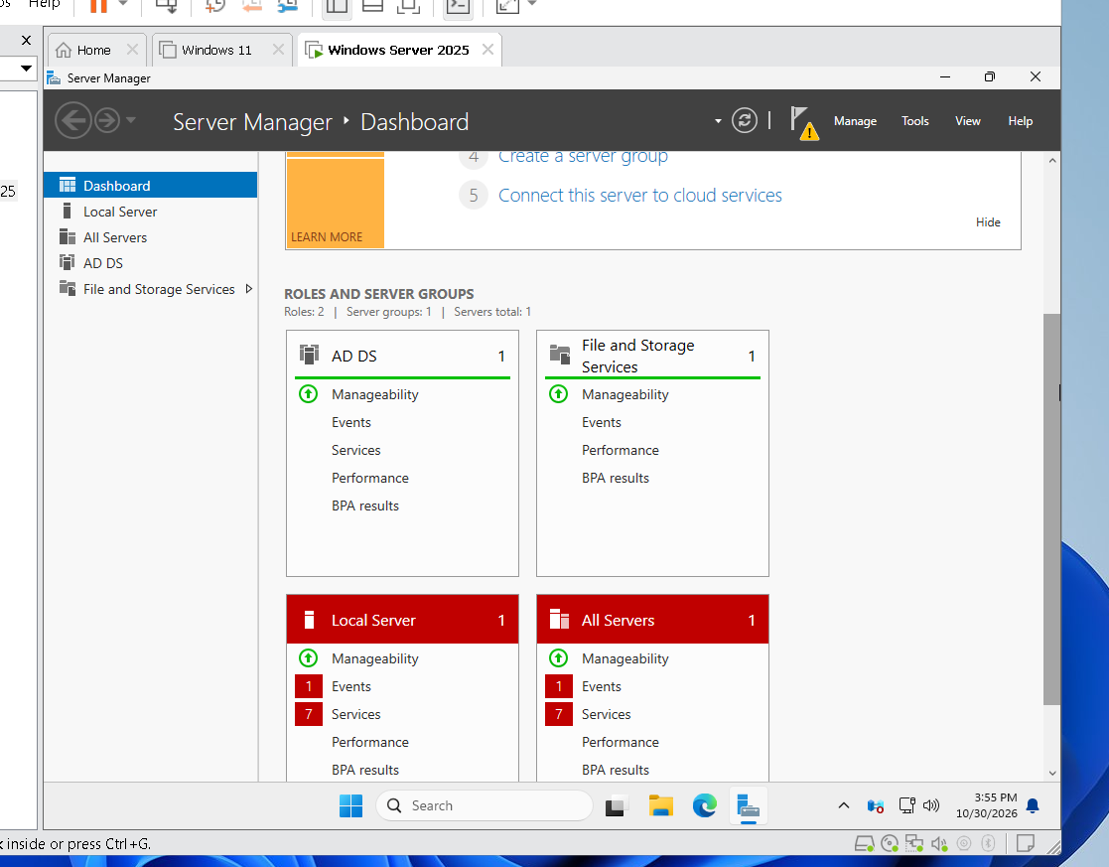



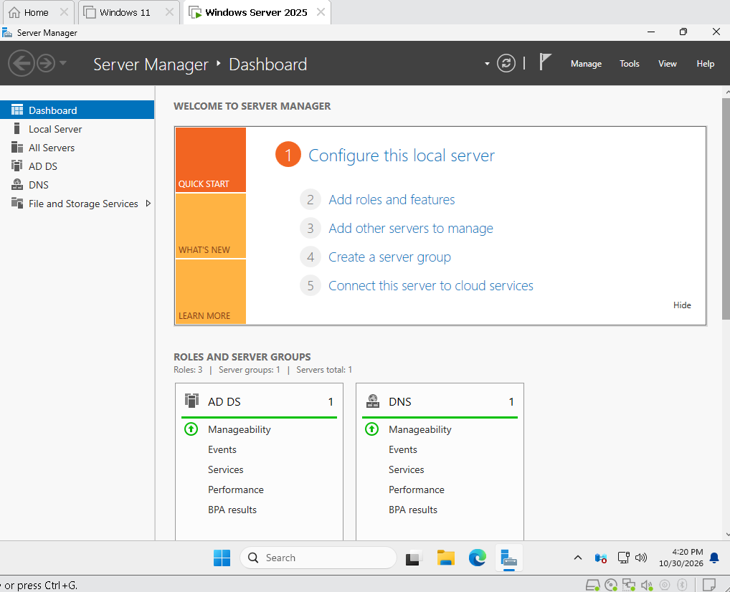

3. Promote your Windows Server to a Domain Controller by creating a new forest with a root domain name of your choice (e.g., mycollege.local). List the options you selected during the configuration.

ANS:

4. Create two new user accounts and one group in Active Directory Users and Computers. Assign both users to the group and describe how you did it. Use the 'Users' container and right-click options in ADUC.

ANS:

